Music in the Schools and Teacher Education Commission (MISTEC)

July 9-13, 2012 in Komotini, Greece

The 2012 MISTEC Seminar is supported by the University of Thrace (http://www.duth.gr/) as well as the Faculty for Musical Studies of the University of Athens (http://www.music.uoa.gr/).

SEMINAR VENUE:
The Seminar will take place at the newly refurbished main hall of the Rodopi Prefecture, an impressive building at the center of Komotini, Greece. The conference room has internet access, video projection, audio system, microphones, and air-conditioning for those hot Komotini days. This building is a 7-minute walk from the Anatolia Hotel, home of MISTEC hotel accommodation.

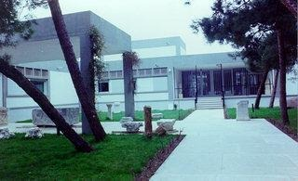

GETTING TO KOMOTINI:

A. Arrival by air: Closest airport is Alexandroupolis (Democritus Airport)— http://www.alxd.gr/—with a number of direct flights from Athens International airport (El. Venizelos).

The distance between the Alexandroupolis Airport and Komotini is approximately 60 kilometers (about 45 minutes by car). The cost for a taxi is around 50-70 euros.

**For those arriving on Sunday in Alexandroupolis, transportation to Komotini will be provided.

B. Arrival by train. You can reach Komotini by train (from Athens and/or Thessaloniki) by two types of trains (the intercity is the faster one). The time that you will need to travel and the ticket price depend on the type of train you choose to take.

- Traveling from Athens International Airport to Komotini (via Thessaloniki) by Train
-OSE (Greek Train Organization): http://www.ose.gr/en/Home.aspx

Tickets for Athens – Komotini (via Thessaloniki )by train
http://tickets.trainose.gr/dromologia/#apo=ΑΘΗΝ;pros=ΚΟΜΟ;date=2011-12-05;rtn_date=2011-12-05;trip=2

- Traveling from Thessaloniki to Komotini by Train

1. http://tickets.trainose.gr/dromologia/#apo=ΘΕΣΣ;pros=ΚΟΜΟ;date=2011-12-05;rtn_date=2011-12-05;trip=2

2. http://www.athensinfoguide.com/index.htm

SEMINAR HOTEL ACCOMMODATION:

- The hotel where commissioners & presenters will be staying is the Anatolia Hotel, located at Aghialou 53, Komotini 69100; Telephone: +30 25310 362 42; FAX: +30 25310 231 70; E-Mail: komotini@anatoliahotel.gr. The choice of Anatolia was based on the quality of accommodation in relation to the offered price and the proximity to the Seminar location. We encourage non-presenting seminar participants to stay at this hotel, if possible. POSTER, PAPER & WORKSHOP PRESENTERS and NON-PRESENTERS MUST ARRANGE FOR THEIR OWN ACCOMMODATION BY CONTACTING THE HOTEL DIRECTLY.

In making your reservation, please use one of the following methods in order to be able to get the special rate for MISTEC SEMINAR:
1. On-line booking. BE CAREFUL! Select as payment method the use of "CREDIT CARD AS GUARANTEE". The whole amount will be paid at the hotel in Komotini. DO NOT use your credit card to charge the whole amount at the time of the on-line booking because the rate at the site is different and the hotel will not be able to reverse the charge.
2. Send an e-mail to komotini@anatoliahotel.gr to book your room, mentioning the MISTEC SEMINAR.

3. Hotel website

http://www.anatoliahotel.gr/portal.php?action=hotel_thessaloniki_hotel_komotini_hotels_thessaloniki_hotels_komotini_welcome&menu=komotini&language=US

- An alternative hotel option, however, is the Olympos Hotel (http://www.hotel-olympos.gr/indexen.htm) is in the center of the city and not far from the seminar venue (approximately 5-7 minutes walking distance) and will be a cheaper option. Prices are forthcoming.

- Students (or those that feel like students) might also choose to have accommodations in the University of Thrace dormitories. Transportation to and from the Prefecture Building will be available.

- For more information or if you have questions regarding the local organization (accommodation, etc.), please address correspondence to: mistec2012@gmail.com

SEMINAR PROGRAM:
All commissioners, presenters, and non-presenting seminar participants should arrive no later than Sunday, July 8, 2012. We will informally meet and greet each other briefly at 19:00 in the lobby of the Anatolia Hotel on July 8th. The Seminar paper and workshop presentations will begin on Monday, July 9th (9:00 am) and end on Friday, July 13th after a “farewell dinner.” A portion of a day at the seminar will be devoted to presentations given by Greek music educators, followed by a half-day excursion in the Komotini region.

TRANSPORTION FROM KOMOTINI TO ISME WORLD CONFERENCE IN THESSALONIKI:
Transportation from Komotini to Thessaloniki for the ISME World Conference will be provided on Saturday, July 14th, for paying seminar participants (if needed). The cost is included in the participants’ seminar booking fee. Reserving a seat will be done on-line at the time of booking for the seminar (www.isme.org).

For tours during the weekend before the ISME World Conference, as well as during and after, please see: http://www.symvoli.gr/conference/isme2012/page/gr_travelling.

SEMINAR BOOKING FEES & APPROXIMATE ADDITIONAL SEMINAR COSTS:
There are four categories of costs for the MISTEC seminar: 1) commissioners & presenters; 2) non-presenting participants; 3) Greek presenters & non-presenting participants; and 4) international and Greek accompanying persons.
Figure 1 indicates the costs of seminar booking fees, accommodation costs (at the Anatolia Hotel only), and approximate extra seminar costs for social events, transportation to Thessaloniki, excursions, welcome and farewell dinners, and daily buffet lunches. The additional seminar fees (CASH ONLY IN EUROS) will be collected on Sunday, July 8, between 18:00-19:00 (at the Anatolia Hotel lobby) AND Monday, July 9, between 8:00-9:00am at the seminar venue.
** For students (regardless of nationality) willing to assist with the practical aspects of the seminar, there will be special seminar provisions and lower prices. Collegiate students who are interested should send an e-mail message to mistec2012@gmail.com by June 1,, 2012.

Figure 1. Anticipated seminar costs.
 | Group | Description | What is included | Amount (€)
1. | Commissioners and All Presenters | Seminar Booking Fee | * Participation in Seminar  * Coffee –breaks (2 per day)  * Welcome dinner  * Farewell reception | 110
 |  | Accommodation for Paper & Workshop Presenters  (6 nights,  Sunday-Saturday) | Bed and breakfast (buffet) in Anatolia Hotel (4*)  (per person, in a double room) | Free of charge for ONE paper or workshop presenter per accepted proposal
 |  | Accommodation for Poster Presenters |  | 30% discount on accommodation for ONE poster presenter per accepted proposal
 |  | Extra Seminar Costs  (Approximate) | * All lunches (buffet) (4 days)  * 1/2 day excursion with dinner or lunch  *Transportation from Alexandroupolis airport on Sunday 8/7/2012  * Transportation to ISME World Conference (Thessaloniki) on Saturday 14/7/2012  * Daily swimming excursions to the sea (provisional, to be discussed) | 60
2. | Non-presenting Participants | Seminar Booking Fee | * Participation in Seminar  * Coffee –breaks (2 per day)  * Welcome dinner  * Farewell reception  * Seminar Proceedings (provisional, see discussion later) | 110
 |  | Accommodation  (6 nights,  Sunday-Saturday) | Bed and breakfast (buffet) in Anatolia Hotel (4*) | B&B per night  Single 45  Double 55  Triple 65
 |  | Extra Seminar Costs  (Approximate) | * All lunches (buffet) (4 days)  * 1/2 day excursion with dinner or lunch  *Transportation from Alexandroupolis airport on Sunday 8/7/2012  * Transportation to ISME World Conference (Thessaloniki) on Saturday 14/7/2012  * Daily swimming excursions to the sea (provisional, to be discussed) | 60
3. | Greek  Presenters and non-presenting Participants | Seminar Booking Fee | * Participation in Seminar  * Coffee –breaks  * Welcome dinner  * Farewell reception  * Seminar Proceedings (provisional, see discussion later) | 70
 |  | Accommodation  (6 nights,  Sunday-Saturday) | Bed and breakfast (buffet) in Anatolia Hotel (4*) | B&B per night  Single 45  Double 55  Triple 65
 |  | Extra Seminar Costs  (Approximate) | * All lunches (buffet) (4 days)  * 1/2 day excursion with dinner or lunch  *Transportation from Alexandroupolis airport on Sunday 8/7/2012  * Transportation to ISME World Conference (Thessaloniki) on Saturday 14/7/2012  * Daily swimming excursions to the sea (provisional, to be discussed | 60
4. | Accompanying Persons  (International and Greek) | Accommodation  (6 nights,  Sunday-Saturday) | Bed and breakfast (buffet) in Anatolia Hotel (4*) | B&B per night  Single 45  Double 55  Triple 65
 |  | Extra Seminar Costs  (Approximate) | * All lunches (buffet) (4 days)  * 1/2 day excursion with dinner or lunch  *Transportation from Alexandroupolis airport on Sunday 8/7/2012  * Transportation to ISME World Conference (Thessaloniki) on Saturday 14/7/2012  * Welcome dinner  * Farewell reception  * Daily swimming excursions to the sea (provisional, to be discussed) | 80

BOOKING:

Opens January 1, 2012, on the ISME website www.isme.org. Deadline for booking is June 1, 2012, to guarantee rates and registration. ISME cannot be held responsible for changes or charges incurred in connection with your travel, hotels, tours and/or accommodation. Travel insurance is strongly advised.
- On this site (www.isme.org), commissioners, international & Greek presenters, international & Greek non-presenting participants, and accompanying persons should book the following:
- Seminar Booking Fee
- Accommodation indication only (Anatolia or Olympos Hotels); RESPONDING AT THIS SITE DOES NOT MEAN THAT YOU HAVE RESERVED ACCOMMODATION. PLEASE SEE INFORMATION ON HOW TO BOOK YOUR ACCOMMODATION DIRECTLY WITH THE ANATOLIA HOTEL OR OTHER OPTION.
- Transportation from Komotini to Thessaloniki (ISME World Congress Meeting).

- Daily registration fees for local Greek music educators will be available and payable at the Seminar venue in Komotini (CASH—EUROS— ONLY).

SEMINAR SOCIAL & CULTURAL EVENTS:

- There will be a half-day tour in the area during the week. Location and day to be announced/decided. There also will be opportunities for swimming in the sea, visiting interesting sites and museums, as well as cultural activities. No need to book at this time.

- There will be provisions for the accompanying persons (e.g., excursions in the area and daily swimming) will be organized for them. Other suggestions for activities include: Traditional Greek dancing lessons, a guided tour of Komotini through smells and tastes.

- A photographic contest “Filming Komotini” will be organized with an exhibition of the participants’ pictures and/or video during the last night of the seminar.

EMERGENCY CONTACT INFORMATION:

- Dr. Smaragda Chrysostomou (MISTEC host organizer): Mobile phone is: +30 6932177463; Dr. Jody Kerchner (MISTEC Chairperson): jody7711@gmail.com (prior to and during seminar)

INFORMATION ABOUT KOMOTINI:

Komotini is the capital of geographical region of Thrace and is located at its the centre, as you can see from the map that follows. Thrace is located at the north-east of Greece, bordering with Turkey (east) and Bulgaria (north).

Komotini is a colorful and traditional small city, full of life (55000 inhabitants). It is the home of the University of Thrace which has a number of different schools (law school, physical education, polytechnic, medical school, school of education and others).

Maps of the Area

- Komotini (Google Maps)

http://maps.google.com/maps/place?ftid=0x14aded2ddc7e4e5f:0x400bd2ce2b9b050&q=Komotini,+Hellas&hl=el&ved=0CA0Q-gswAA&sa=X&ei=tc7cTs2YGqKoiQLu1JWbDA&sig2=eb3oIUMdOxXVWRZlPFAO1w

http://maps.google.com/maps/place?ftid=0x14ade93069917e37:0x500bd2ce2ba2540&q=Komotini,+Greece&hl=en&ved=0CBsQ3w0&sa=X&ei=Yb3mTpnXPMG28ga347znCg (in English)

Figure 2. Komotini.
(Large purple dot signifies location of Komotini, relative to Alexandroupolis and Thessaloniki)

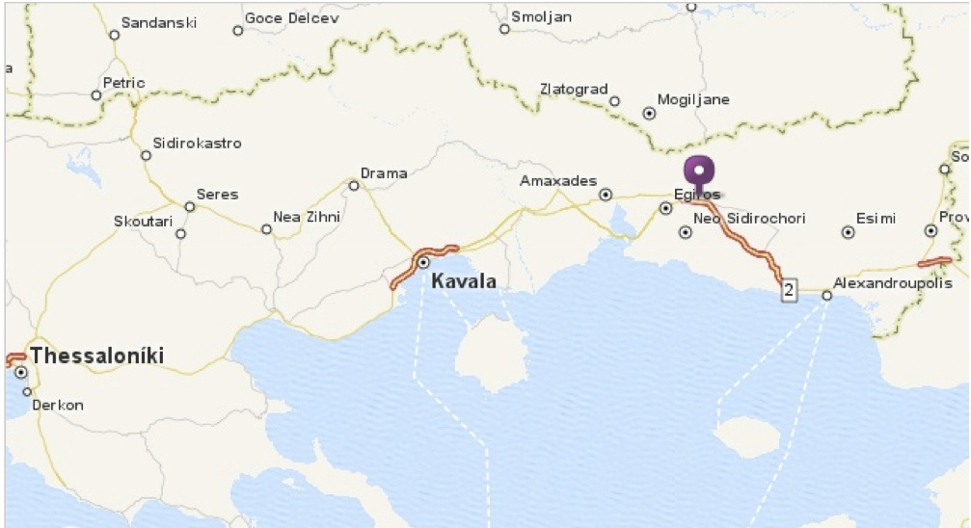

Thrace comprises some of the most interesting and rich Greek but also European wetlands. Two rivers (Evros and Nestos ) that almost cut through the land, eject to the Aegean Sea and form deltas where rare and protected species of animals do live. The said wetlands are classified as special protection areas by international treaties and through the years many scientists as well as tourists are attracted to these places.

Figure 3. Rodopi Prefecture.
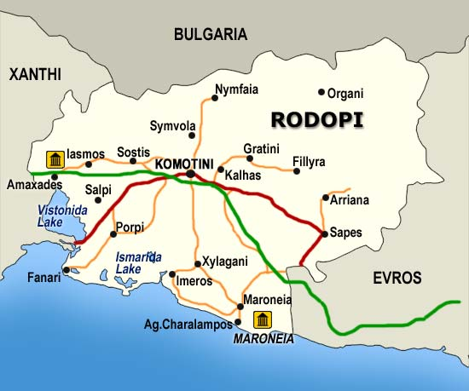
The Aegean Sea, that washes the southern part of the area, forms huge beaches, presents a great relief of forms and structures, which is attracting for every tourist and taste. Beaches with crystalline waters, some of them sandy through out the greatest part and some other rocky are ideal for fishing, diving or any other under water activity. Some of the villages in the coastal such as Fanari or Porto Lagos etc, are today important tourist centres with significant tourist infrastructure and offered services.
The mountains of the region –Rhodopi and Menoikio-as well as the island of Samothraki, are covered with forests of rare flora and fauna.

Important historical monuments as well as archaeological sites and rare treasures that are hosted in the museums of the area (Samothraki, Komotini, Avdira etc) offer an extraordinary chance to connect with the past; they offer as well the possibility to gather information about the historical and pre-historical past of the region.
The abundance of the customs and the folkloric festivities is manifest; the visitor can find out in every single village or area, regional customs of Thrace or of Macedonia or even of the northern Thrace and Pontus, all of them habits of people that came into the area as refugees during the period of 1922-23.
The participation of the believers to local fairs organized by local monasteries and churches in order to honour a saint, apart form the deep religious spirit preserves the Byzantine colourful atmosphere of the area, which for centuries constituted the geographical as well as cultural surrounding of Constantinople.

The visitor in the area of Thrace will find it very difficult to choose a special journey and visit the archeological sites because there are many, of many and different historic but also pre-historic periods and we can find them all over the region.

At the coasts of the regions of Evros and Rodopi there are two beautiful caves, one in Makri and another in Maronia, and people living there say that these are the caves where the Cyclopes lived once.
Mesimbria a village existing since the ancient Greek period (or else called Zoni according to newest estimations) at the coasts of Evros (journey Alexandroupoli - Makri - Dikella) as well as Maroneia (journey Komotini-Xylagani) westwards in the region of Rodopi remind of the ancient colonization and the flourishing period of the Greek civilization.

The archeological Museum of Komotini (for further information contact: +30 25310 22 411) is considered to be one of the most worthy in the region not only for the number of exhibits but also for the archaeological importance of the findings.

At the coastal zone of the region of Xanthi there was built the Ancient Greek city of Avdira, is considered that is the city of birth of Dimocritus and Protagoras.There is also a very nice museum in Avrdira where an important number of archaeological findings are exhibited.

Komotini is a modern town, vibrant, full of students during the academic year, but at the same time with a traditional core. The old town with the narrow streets and small shops, remind the modern tourist of past times. Yet modern cafes, bars, restaurants and shops around the main square are clearly within the 21st century style.

WEBSITES WITH INFORMATION ABOUT KOMOTINI:
http://www.europedirectkomotini.eu/eud/en/
http://www.duth.gr/
http://www.gtp.gr/LocPage.asp?id=11036
http://www.mlahanas.de/Greece/Cities/Komotini.html
en.wikipedia.org/wiki/Komotini

VIEWS AROUND KOMOTINI:

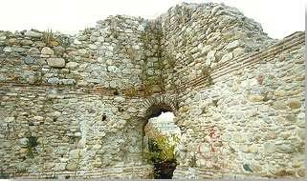
Byzantine Castle (4th Century A.D.) in Komotini

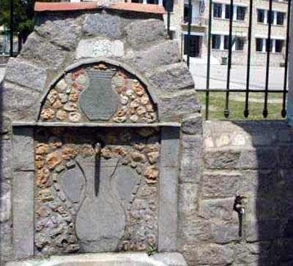
Faucet in Komotini (left)

Democritus University of Thrace (right)
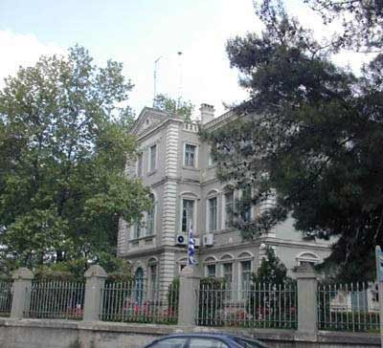
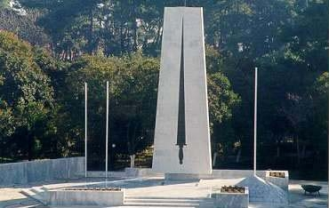Central War Memorial
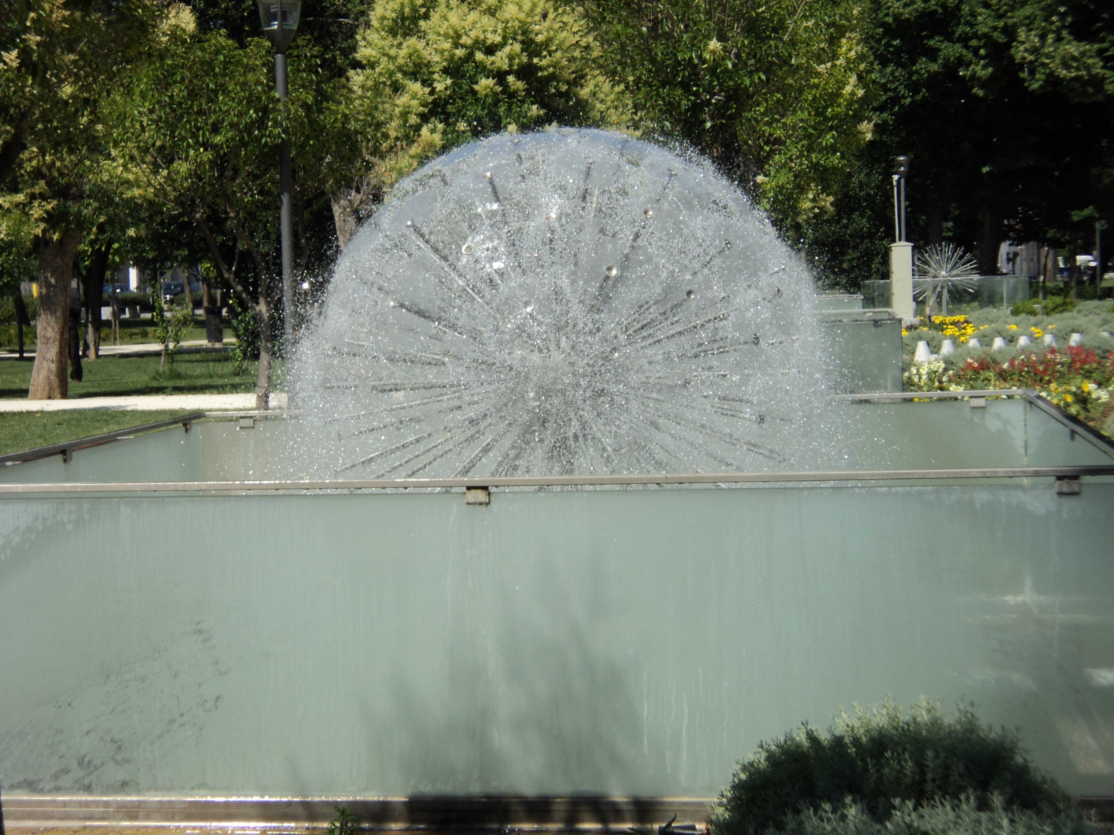
Fountains in the downtown park (left)

